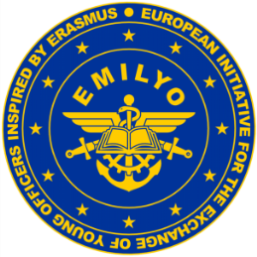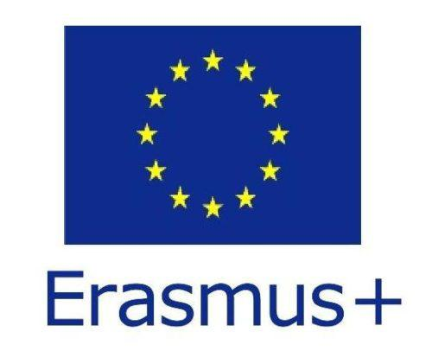

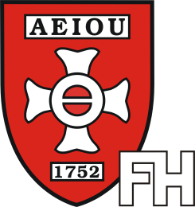

**Theresan**

**Military Academy**

**Certificate**

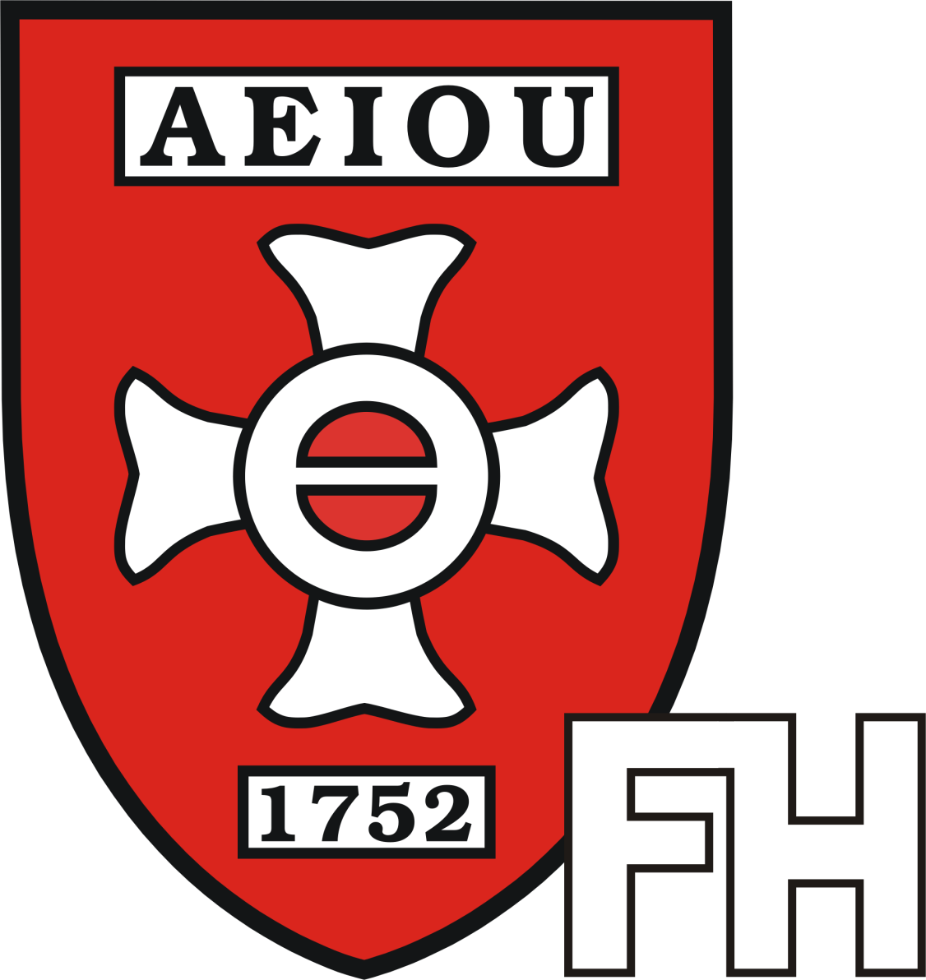

This is to certify that

**LtCol Marcin BIELEWICZ, PhD**

Head of Department

Language Department

Military University of Land Forces Wroclaw

Poland

taught 16 teaching hours

during the Common Module on Common Security and Defence Policy (CSDP)

at the FH Bachelor Programme Military Leadership

from 11th of November, 2019 to 15th of November, 2019.

Topics taught: The European Union, CSDP History, Evaluation of Syndicate Work.

Wiener Neustadt, the 15th of November, 2019

|  |  |
| --- | --- |
| The Course Director: | The Head of Institute: |
|  |  |
| (Col Assoc. Prof. Harald GELL, PhD) | (BrigGen Mag. Jürgen WÖRGÖTTER) |